Eta Kappa Nu

Electrical Engineering Honor Society

Initiation Test 2017
Due by April 17, 2017
Submission options:
(a) Scan answer sheet and email: Matthew.Valenti@mail.wvu.edu or David.Graham@mail.wvu.edu
(b) Bring to Dr. Valenti’s office: AER 361 or Dr. Graham’s office: AER 355 (leave under door if nobody there)

Turn in just the answer sheet (last page of the test)

- West Virginia University’s chapter of Eta Kappa Nu is the __________________ chapter.

- Eta Kappa Nu was founded by _______________________ in the year of _________.

- Eta Kappa Nu's symbol is the:

  - The Wheatstone Bridge
  - The Capacitance Bridge
  - The Bent
  - The P-N Junction.

- Dr. _________________ is the Eta Kappa Nu faculty advisor.

- Eta Kappa Nu is a(n) _____________ Honor Society for Electrical and Computer Engineers.

  - West Virginia University
  - National
  - International
  - Universal

- Match the 2015 - 2016 officers with their respective position:

____ President a. Catherine O’Hearn
____ Vice President b. Katherine Warner
____ Bridge Correspondent c. Kyle Smith
____ Corresponding Secretary d. Benjamin Upton
____ Recording Secretary e. Ivy Kwan
____ Treasurer f. Mary Donovan

- Write the decimal number 6831 in
  - Base 2
  - Base 8
  - Base 16

- What is the average power dissipated by an electric heater with a resistance of 50 Ω drawing a current of 30sin(30t) A?
  - 0 kW
  - 10 kW
  - 14.14 kW
  - 22.5 kW

- Write one line of code to implement each of the following in MATLAB (no loops or semicolons allowed):
  - Sum all odd integers from 1 to 100 without using the sum function.
  - Create the following matrix
1 2 3 4 5 6 7 8 9 10
2 4 6 8 10 12 14 16 18 20
3 6 9 12 15 18 21 24 27 30
4 8 12 16 20 24 28 32 36 40
5 10 15 20 25 30 35 40 45 50
6 12 18 24 30 36 42 48 54 60
7 14 21 28 35 42 49 56 63 70
8 16 24 32 40 48 56 64 72 80
9 18 27 36 45 54 63 72 81 90
10 20 30 40 50 60 70 80 90 100
  - Sum of all numbers from 1 to 100 that aren’t divisible by 5

- Express the following function as a sum of products:

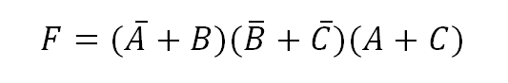
Pick from among the following multiple-choice answers

a) $F=ABC+A\overline{B}C$
b) $F=ABC+\overline{A}\overline{B}C$
c)$F=AB\overline{C}+A\overline{B}C$
d)$F=AB\overline{C}+\overline{A}\overline{B}C$

- A second order, continuous-time system is defined by the following transfer function:

$$H\left(s\right)=\frac{20}{s^{2}+2s+4}$$
If the system receives a step input, what is the steady state output, $y_{ss}(t)$?
- 0
- 1
- 5
- ∞

- For the circuit below, V_{DD} = 10V and V_{OUT} = 2V. Assume the transistor is in saturation, V_{TN} = 1.2V, V_{DSQ} = 5V, and V_{GS} ≈ I_{D}*R_{S}. The current across the bias resistors (I₁) is equal to 0.05*I_{D}, and R₁ || R₂ = 96. Find R₁, R₂, R_{D}, and R_{S}.
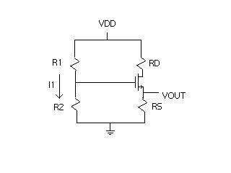

- For h(t) and f(t) sketched below, the convolution y(t) = h(t)*f(t) has y(1) = :
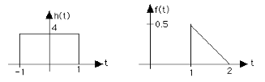

    - 1
    - 2
    - 3
    - 4
    - 0.5
    - 0
    - 0.25
    - None of the above

- For the circuit below, find V_{i}.
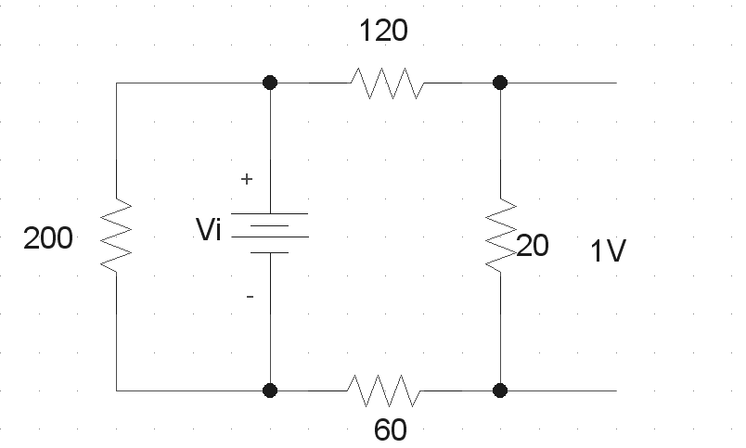

- The elements in Figure 1 and Figure 2 are linear and the sources are DC. As seen by terminals a and b, the circuit in Figure 1 can be equivalently represented by the circuit in Figure 2 with VS(V) and R(Ω) values as follows:

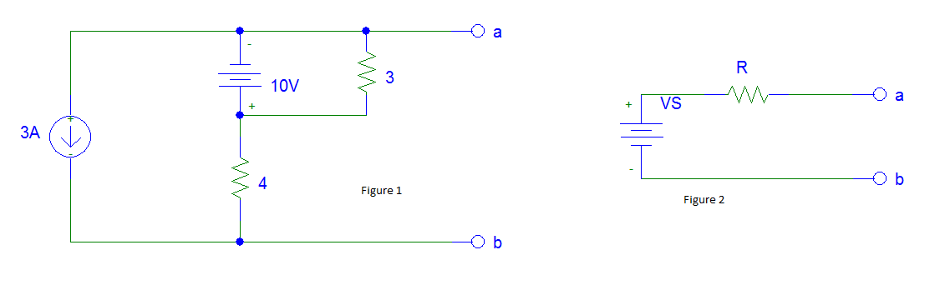

VS R

- -22 4
- -22 7
- -21 7
- -21 4

- Three impedances of 4+j3Ω are ∆-connected and tied to a three-phase 208-V power line. What are the phase current, line current, and power factor?

 | I_{Φ} | I_{L} | PF
a. | 24.0 A | 41.6 A | 0.8 lagging
b. | 41.6 A | 41.6 A | 0.8 leading
c. | 41.6 A | 72.1 A | 0.8 lagging
d. | 72.1 A | 72.1 A | 0.8 leading

- Design a high-pass RC filter with a corner frequency of 10 kHZ.

- Magnetic flux density, B, and magnetic field strength, H, may experience changes at the interface of materials whose magnetic properties differ from one another. Consider the following:

- magnitude of B
- normal component of B
- tangential component of B
- magnitude of H
- normal component of H
- tangential component of H

What combination represents the properties of an electromagnetic wave that are continuous (i.e, do not change) across such an interface?

- i and ii
- ii and vi
- iii and v
- iv and vi

- For the circuit shown, assume Z1 = 20kΩ and Z2 = -j80kΩ. Vout is most nearly:
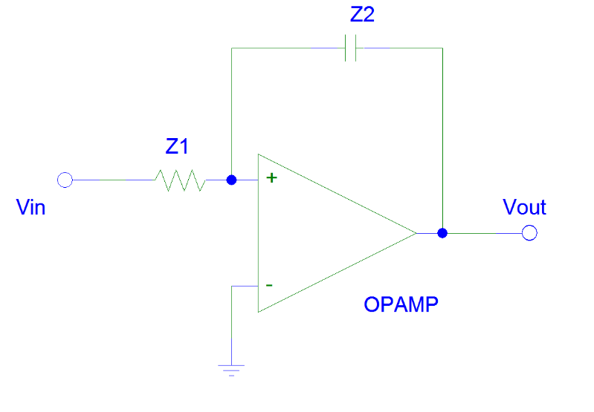
- 4∠-90° Vin
- 4∠90° Vin
- (1-j4) Vin
- (1+j4) Vin

- When a CPU fetches an instruction word from memory, the word contains an operation code that indicates the type of operation the CPU is to perform. A computer may use various addressing modes to specify the operand location. One such addressing mode is illustrated below, where R designates some register within the CPU and d is a constant embedded in the instruction word.

INSTRUCTION WORD OP CODE R d

OPERAND ADDRESS:
∑

R:

Which of the following terms best describes the addressing mode used by the instruction above?
  - Immediate addressing
  - Direct addressing
  - Indexed addressing
  - Indirect addressing

Answer Sheet: Name:__________________________

- _______________
- _______________ __________
- _______________
- _______________
- _______________
- _____________________
(sort the letters a through f in the proper order)

- _______________
- _______________
- _______________
8. ________________
9.
- _______________
- _______________
- _______________

- _______________
- _______________

- R1= ________
R2=__________
RD=___________
RS=___________

- X(f)=_______________
Draw your sketch to the right
- Vi=_______________

- _______________

- _______________

- Draw your circuit diagram here:

- _______________

- _______________

- _______________

